**Modelling and Simulation of a Phosphoric Acid Fuel Cell (PAFC) Alongside an Energy Storage System in MATLAB/SIMULINK.**

**Abstract:**

This research proposes a transformative grid-integrated power generation system combining Phosphoric Acid Fuel Cell (PAFC) with advanced thermodynamic energy generation architecture. The proposed system utilizes a solar powered cracking mechanism of higher carbon number alkanes which will provide for the need of hydrogen, which is the driving force of the fuel cell and Oxygen is extracted from ambient air and utilised in Fuel Cell, integrated with a multi-stage thermodynamic power generation schematic. A three-stage configuration generates a primary supply of electricity via PAFC, stores it as mechanical energy in a flywheel energy storage system via a motor and reconverts to send it to the grid via Generator whereas a supplementary Organic Rankine thermodynamic cycle utilizes by-products such as waste heat and water from the fuel cell to generate Electricity. This model estimates the cell output voltage theoretically, taking into consideration the Nernst -potential, Activation loss, Ohmic loss, and the loss of concentration. By systematically harnessing excess water and thermal energy, the system demonstrates remarkable potential for enhancing renewable energy efficiency and power generation. The core methodology employs the use of software such as MATLAB and Simulink, to analyse the system processes. Control optimization strategies were developed leading to regulation of these systems and control for further optimization.

KEYWORDS:

PAFC, Solar powered cracking mechanism, Flywheel Energy Storage System, Organic Rankine Cycle, Waste heat utilization.

**Introduction:**

Due to the increasing demand for energy, alternative and renewable energy sources have gained significant popularity. People are becoming more aware of the environmental impact and the dwindling reserves of fossil fuels. Technologies like fuel cells, wind turbines, micro-turbines, and photovoltaic cells are widely used as alternative energy sources, collectively referred to as distributed generation (DG). Among these, fuel cells have garnered interest across different generations because of their capability to generate both electricity and heat.

A Fuel cell is an electrochemical cell. Electrical energy is generated via a chemical reaction. In PAFC Phosphoric Acid(H3PO4), Hydrogen Gas, Platinum Catalyst (Electrodes) and Air is utilized that contains CO2 as Oxidant. The Basic components of a fuel cell include

1) Anode (Where Oxidization Occurs)

2) Cathode (Where Reduction Occurs)

3) Electrolyte (Allows ion transfer but separates the reactants)

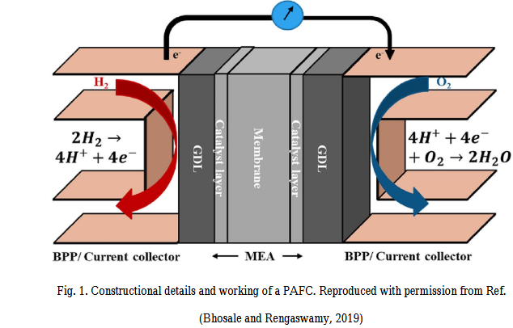

The reaction in a fuel cell produces Water, Heat and Electricity. Reactions that occur at the respective electrodes are summarized below:

Classification of fuel cells are of five types. Phosphoric Acid Fuel Cell (PAFC), Proton Exchange Membrane Fuel cell (PEMFC), Solid Oxide Fuel Cell (SOFC), Alkaline Fuel Cell (AFC) and Molten Carbonate Fuel Cell (MCFC). The PAFC operates on Temperatures ranging between (150-220) Celsius (302-428) Fahrenheit. The PAFC utilizes phosphoric acid as an Electrolyte, positively charged Hydrogen ions are transferred to Negative Terminal via electrolyte. Electrons formed at Anode travel via external circuit, generating electricity along the path, before moving back to cathode while protons move toward cathode via semi permeable membrane. Water is discharged from the cell after being created by electrons, hydrogen ions, and oxygen. These reactions take place at electrodes utilizing Platinum catalyst. Carbon monoxide (CO) production surrounding electrodes can (toxic) a fuel cell. PAFC cells have the benefit of tolerating carbon monoxide (CO) concentration of approximately 1.5 percent at two hundred degrees Centigrade. Another benefit of concentrated phosphoric acid electrolytes is that they may work well beyond the boiling point of water. The Waste heat generated from PAFC is utilised in Organic Rankine Cycle to generate electricity (Cogeneration).

The efficiency of a PAFC ranges from (40-60) % but it can be enhanced to 80% with cogeneration of electricity from waste heat. The disadvantage of PAFC is its High Production and maintenance cost therefore not beneficial for commercial use. The bipolar plates of a fuel cell are to be protected from corrosion using corrosion resistant films for better PAFC lifetime and optimizing electrolyte performance. The electricity generated from PAFC is DC so to utilize it we must convert it into Alternating Current through a power conditioning phase installed at the output of Fuel Cell. The applications of a Phosphoric Acid Fuel Cell include small scale Power production devices, Defence and Military while after cogeneration it can be utilized in Hospitals. It requires a longer startup as it operates at a greater temperature than a Polymeric exchange fuel cell technology(Einanlou et al., 2023). It is essential to choose a fuel cell set point (cell voltage and relative current density) until the system requirements have been met(Heinzel et al., 2014; Okumura, 2013). The integration of the PAFC with the Flywheel energy storage system includes a power conditioning phase to convert DC electrical energy of the Fuel Cell into AC supply connected to a motor for alteration of Electrical energy into Mechanical Energy whose shaft is integrated into a Flywheel to store energy in the form of Mechanical energy and to utilise this stored mechanical energy the shaft of the Flywheel is interconnected with the shaft of the Generator via a coupling mechanism.

**Literature Review:**

The Fuel Process generates less chemical and sound pollution. They are modular and very economical when powered with appropriate fuels. With the proper design approach, their efficiency is regardless of the Load. They may also operate hands-off, resulting in reduced wage costs in developed units. Present acid fuel cells utilize phosphoric acid (PA) as an electrolyte with clean, reformed fuels or gasifier-clean coal gas.(Chen et al., 2015) To generate H2, the PAFC modules require fuel efficient systems, which restricts fuel choices to clean, light HCs and methanol if accessible. The most appealing advantages of PAFCs for electric companies are their quick building and installation timeframes, modularity, efficiency, and easiness of sitting. Since fuel cells are modular, they may be available and in the rate base rapidly after an order is placed. As the electrolyte, phosphoric acid (H3PO4, PA) is often confined in Matrix Typically Silicon Carbide. The platinum anode and cathode electrodes have changeable loadings on a carbon-based surface for diffusion of gas. The Oxidant as well as the Fuel sources are cycled through Bipolar Plates (BPPs) opposing sides of Electrolyte. Just at Anode, Hydrogen is oxidized to form protons and electrons during Process. Protons move through Electrolyte, whereas electrons pass the external circuit, Generating a current. Water is formed when protons and electrons contact oxygen at the cathode. The heat emitted in procedure is frequently used to heat water, space heating systems, and for other purposes(Zhang et al., 2012).

Since hydrogen oxidation is a quick process, the reaction of oxygen reduction at Cathode is slower dictates the speed of Reaction, for example: Current Density. At standard pressure and temperature (STP) parameters (1atm, 298.15 K), the reaction of Hydrogen with the oxygen generates 287 kJ per Mole of Hydrogen gas. It emphasizes that when one mole of hydrogen interacts with half a mole of oxygen, one mole of water is formed, delivering 287-288 kJ of Energy for Example: enthalpy or heat of reaction. It is the greatest quantity of energy that can be taken out from fuel cells. But, because of the unavoidable losses caused by the Thermodynamics Barriers (entropy loss), operation departure from Standard Temperature and Pressure conditions, fuel crossovers, over potentials, cells Potential falls to lower tiers(Wilailak et al., 2021). As a result, the thermos neutral potential gives the potential proportional to the enthalpy of Reaction deprived of accounting for the losses. When in a fully dissociated ionic form, phosphoric acid, an inorganic acid, is an excellent ionic conductor. Because of its strong ionic conductivity, it is an outstanding option as Electrolyte in PAFC. When it is Doped with PHOSPHORIC ACID, the matrix shows outstanding chemical, electrical and thermal stability. The Sic connected with PTFE (0.3 -0.4 mm in thickness), which is used as the matrix, holds the electrolyte with minimum leakage and is created by dispersing Sic in Deionized Water with PTFE (4-17 weight percent) as binder. Slurry is than ball milled and taped Cast on layers of Catalyst to produce the Electrode Matrix Layer(Staffell et al., 2019). The matrix is Ionically- conducting but not electrically conductive. The thin layer of silicon carbide minimizes the cell's internal resistance, which enhances its performance. Due to its advantageous characteristics, low density, high strength, temperature resistance, thermal shock resistance, wear resistance, chemical resistance, low thermal expansion, and good thermal conductivity are just a few examples. Silicon carbide has been recognized as an excellent material(Li et al., 2022).

To minimize corrosion in the early phases of PAFC development, a dilute electrolyte has been used. But concentrated electrolyte is used, that reduces water vapor pressure, enabling water management to be more efficient and simpler than phosphoric acid fuel cells. The longevity of PAFC Stack (1 kilowatt) in continuous operation exceeds 5000 h, indicating exact tailored location of active sites on the support and particle size distribution, along with stability and improved acid holding capacity of Silicon carbide matrix. However, each enhancement to the Constructed Ports sacrifices the stack's capacity to run sporadically(Li et al., 2022). The Polybenzimidazole (PBI) is a superior alternative than standard Silicon carbide Matrix due to its strong proton conductivity, reduced gas permeability excellent thermal, mechanical and chemical durability. Membranes composed of poly (2- 5 -benzimidazole) can produce through using membrane casting process, in which polymer is Dissolved into solvent like methane sulfonic acid, formic acid, sulfuric acid and many others. Solution is applied to a flat surface or a petri dish, and heated in a controlled condition, the membrane is left behind owing to solvent evaporation. The uniformity of Membranes is reliant on Boiling Point of solvent. Even as the Phosphoric Acid concentration of the PBI grows, it also increases the proton conductivity, which has an impact on mechanical stability. As a result, an adequate acid content and doping duration are selected to achieve a balance between conductivity and stability. In the context of PAFCs, the Amount and distribution of phosphoric acid in Membrane is significant(Sui et al., 2021). The fundamental cause of membrane deterioration has been acid leakage from a membrane, which causes a reduction of ionic conductivity. The Grotthus mechanism is used to transfer protons via acid-doped membranes. Due to the reduced evaporative nature of acid species, the partial pressure of water in the membrane is small, hence greater humidification of gases is not necessary. During cell operation, however, water is created via dilute interactions from the acid, altering its concentration. After that it has been increased When the cell ceases Membrane ballooning. This encourages acid leaching (migration, evaporation) out from Membrane, resulting in drop in Ionic conductivity as a result loss of Cell performance as time passes. Nonetheless, the spilled Acid affects other cell components like GDL and BPPs and others causing them to degrade together. For PBI based Membranes. PA emission can be determined by using Molybdenum Blue approach(Auld et al., 2013). The result of the interaction of phosphoric acid with acid ammonium molybdate and their Product that moreover decreases to molybdenum blue with use of ascorbic acid. Phosphoric acid Leaching was shown relating directly to solutions Blue Colour Intensity. When Cell was operating in constant current mode, the cathode suffered the most PA loss due to the Constant creation of Vaporized Water at Cathode. Rapid start and quit operations are also shown to be damaging to Constant Current Mode Operating on a given period (4605 hours). Like previously noted, the water stress caused by vapor production was blamed for acid leaching and hence continued to increase charge transfer resistance(Hosseini & Wahid, 2016)

**PAFC Modelling:**The approach uses SIMULINK and MATLAB software to model the PAFC. The input parameters to the fuel cell are the Temperature(K), the partial pressures of Hydrogen, Oxygen and Water. The system shows the response of a single cell of the PAFC against varying input parameters.   
  
Nerst Potential:  
The system calculates the Nerst Potential by using the partial pressures of Hydrogen, Oxygen and Water along with the temperature. The Nerst Potential is calculated by the governing Nerst equation. The Nernst equation provides the relation between the cell potential of an electrochemical cell, the standard cell potential, temperature, and the reaction quotient. The Nerst equation is as follows:  
  
 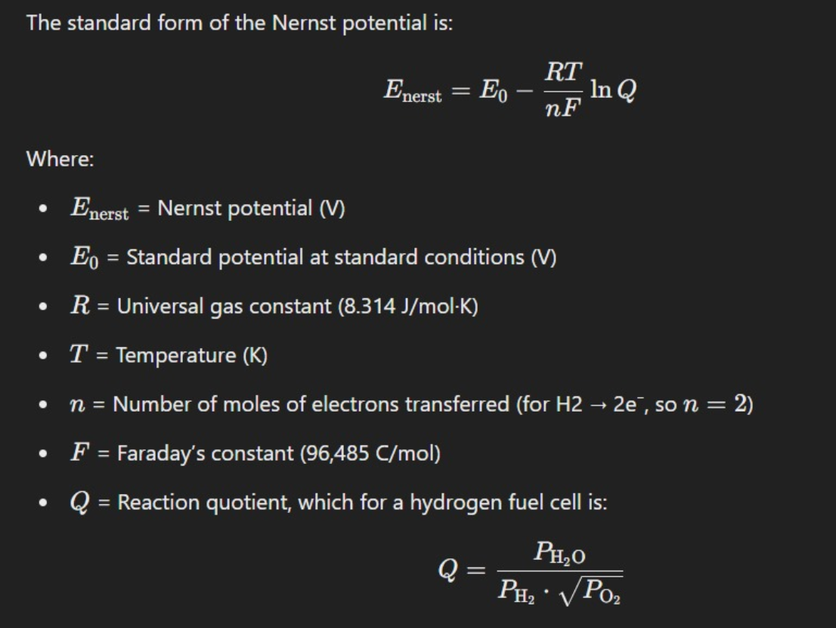  
  
Fuel Cell Voltage:

The system then calculates the voltage losses which account for the decrease in voltage as it is conducted across the fuel cell. The 3 major types of voltage losses in the fuel cell are Ohmic Losses, Concentration losses and Activation losses. The Voltage of the fuel cell is calculated by the following equation:  
  
Ohmic losses:  
These losses arise due to two resistances that occur in the fuel cell. The first is the resistance that the electrons face when they are flowing through the outer circuit. The second is the resistance that the protons undergo when they are flowing through the proton exchange membrane. These resistances result in the loss of potential of the fuel cell. The total ohmic resistance can therefore be modelled as the sum of electron ohmic losses and the proton ohmic losses. The voltage drop due to these resistances can be found out by utilizing the Ohm’s law equation:  
  
  
Concentration losses:  
Also known as Mass Transport Losses these losses occur when the rate of mass transport of a species to or from the electrode limits current production. It occurs generally at higher current densities due to limited mass transfer of [chemical](https://www.sciencedirect.com/topics/engineering/chemical-specie) species by diffusion to the electrode. Thus, insufficient mass transport causes reactant depletion or product accumulation. These losses can be quantified by the following equation:  
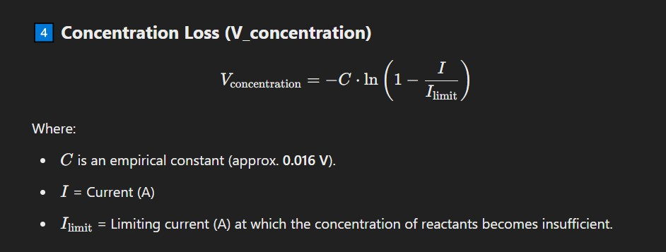

Activation losses:  
The activation energy is related to both chemical and electrical reactions. They can be distinguished by the reacting species. The voltage drop due to the activation loss can be minimized by rate parameters and activation energy of one or more rate limiting reaction steps. The equation of activation loss is observed as below:  
  
  
  
Simulink Modelling:  
The following models were created using Simulink on MATLAB R2024b. The following figure shows the modelling done to calculate the “E Nernst voltage”.  
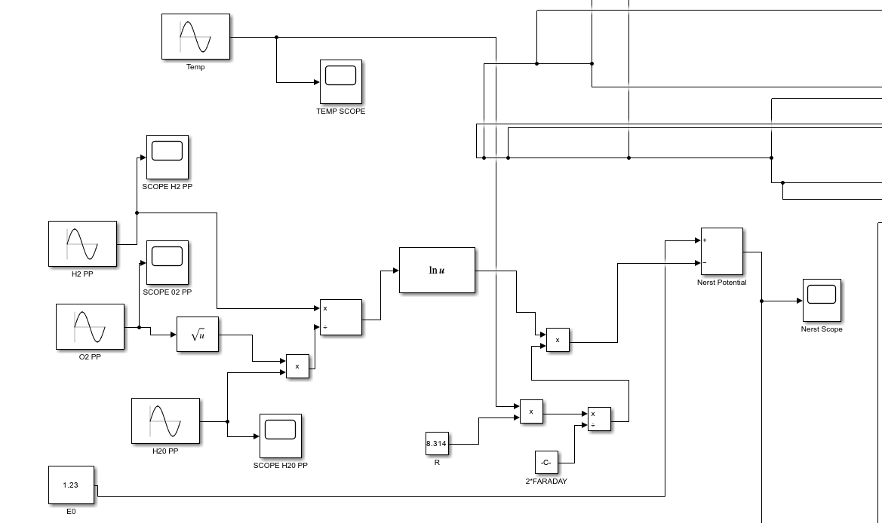  
  
The 3 voltage losses in the fuel cell ie the Ohmic, Concentration and Activation losses are calculated by modelling in Simulink and are shown below:  
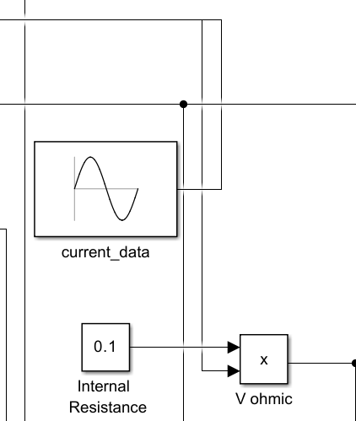  
Ohmic Losses  
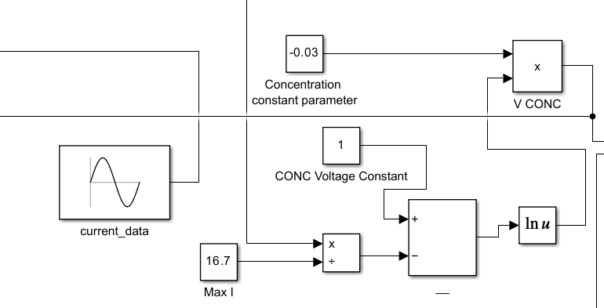  
Concentration losses  
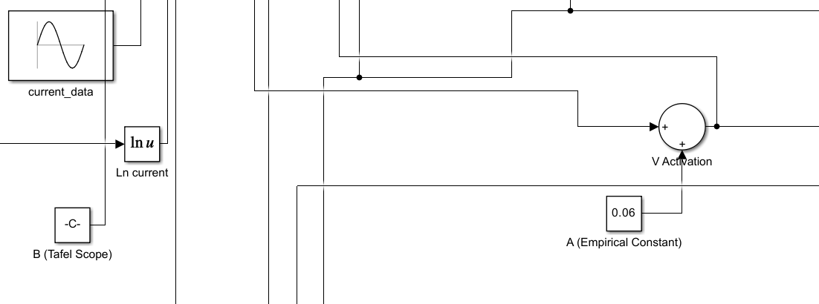  
Activation losses  
  
**Fuel Cell Stack:**  
The above mentioned equations and models presented are for one cell of the fuel cell stack. The total voltage output from the stack depends on the number of cells in the fuel cell and can be found out by the following equation:  
V Stack = n*V cell  
Where n = numbers of cells in the fuel cell stack.  
  
When considering the design of a fuel cell stack, usually several limitations should be considered. Some of these limitations may include the following:

1. Size, weight, and volume at the desired power
2. Cost
3. Water management
4. Fuel and oxidant distribution

These parameters define how well the fuel cell stack functions in each state of conditions.   
  
The Voltage output of the whole system can also be found out by using the following equation:  
V System = n * V Stack  
Where n= number of fuel cell stacks in the whole system.  
  
**Heat Energy Recovery System:**  
We know that no fuel cell is 100% efficient thus this approach has modelled the PAFC’s waste heat energy to be utilised by an Organic Rankine Cycle aka ORC.The waste heat from the PAFC can be captured and sent to the ORC which can be boost started by this heat to run it’s operation.  
  
**Organic Rankine Cycle:**  
The following diagram shows the different components involved in the ORC’s operation:  
  
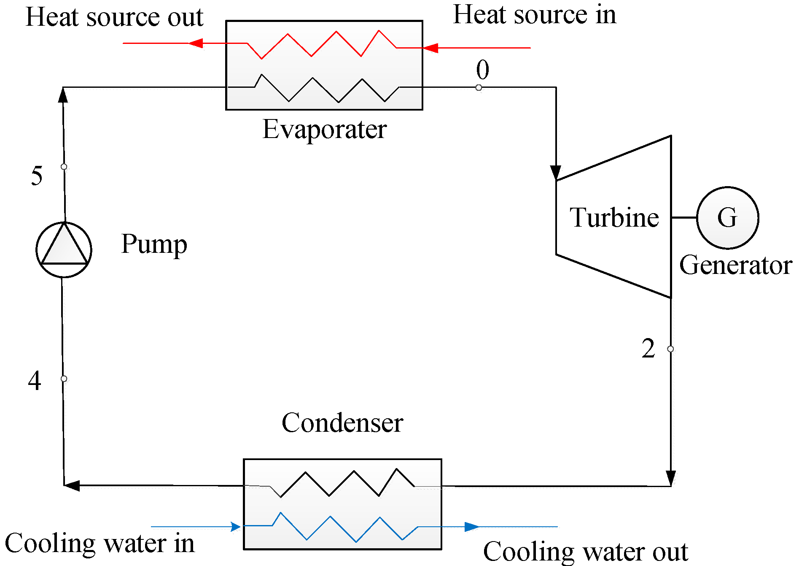  
The working fluid for the ORC can be water or other organic fluids (like R-134a, toluene, or pentane) which is preheated to elevated temperatures by utilising the waste heat from the PAFC.The following is the T/s diagram for the ORC:  
  
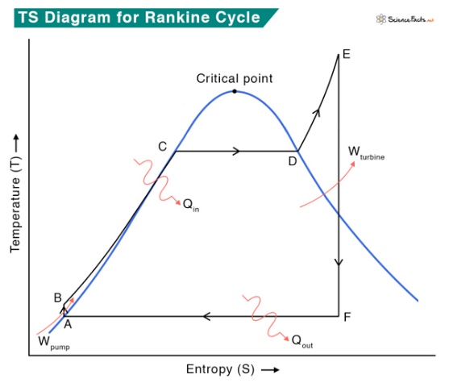  
**Pump:**  
The pump pressurizes the working fluid from the condenser before it enters the boiler. The work done by the pump to compress fluid can be estimated from the enthalpy (H) change of fluid before entering (H1) and after leaving (H2) the pump.

Wpump = H2 – H1

We assume an ideal scenario where no heat is lost to the surroundings during this step. Also, the pump requires little energy input, which is negligible for thermodynamic calculations.  
  
**Boiler:**Pressurized fluid from the pump enters the boiler and boils until it forms superheated steam. The amount of heat (Qin) entering the boiler is equal to the enthalpy difference H3 and H2 where H3 and H2 indicate the enthalpies at the boiler outlet and inlet, respectively  
Qin = H3 – H2  
The pressure inside the boiler does not change during this step, so no work is done.  
  
**Turbine:**   
The turbine undergoes rotation in order to produce work by the expansion of the superheated vapor. It is a work-producing device. This work output is utilized for the operation of the pump and the generator to produce electricity. The turbine work output is calculated by  
 wturb,out = H3 − H4.  
  
**Condenser:**  
Superheated fluid from the turbine condenses into liquid fluid. Heat is given out during this process, which is equal to

Qout = H4 – H1  
The efficiency of the ORC can be found out by the following set of equations:  
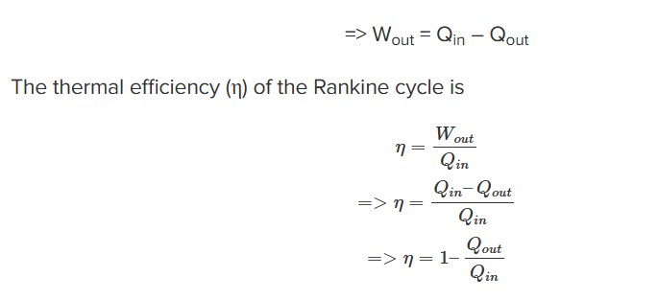  
  
**Flywheel:**  
The approach used in this paper is that the electricity produced by the PAFC is first stored in the Flywheel and then released to the grid when required. Flywheel energy storage, also known as kinetic energy storage, is a form of mechanical energy storage that is a suitable to achieve the smooth operation of machines and to provide high power and energy density.  
  
 In flywheels, kinetic energy is transferred in and out of the flywheel with an electric machine acting as a motor or generator depending on the charge/discharge mode. Permanent magnet machines are commonly used for flywheels due to their high efficiencies, high power densities, and low rotor losses [54]. Other electrical machines such as induction, bearing-less and variable-reluctance machines vary in terms of limitations in application speed, idling losses, vibration, noise and cost. Charging energy is input to the rotating mass of a flywheel and stored as kinetic energy. This stored energy can be released as electric energy on demand. The rotating mass is supported by magnetic bearings which operate in a vacuum to eliminate frictional losses during long-term storage and safety issues [55]. Compared to batteries and supercapacitors, lower power density, cost, noise, maintenance effort and safety concerns are some of the disadvantages of flywheel energy storage systems [126, 127]. To improve their power density, Toodeji [127] proposes a novel design for a combined system in which supercapacitors are located inside the flywheel rotating disk. This allows exchanging pulsed power as well as storing large amounts of energy. The kinetic energy is reconverted at time of need to electrical energy and sent to the grid via the use of power cables.

**Cell Performance:**

Fuel cell performance is influenced by several factors, including pressure, temperature, the composition of reactant gases, and fuel utilization. Contaminants present in the fuel or oxidant gases can also adversely affect performance. For instance, performance diminishes when the reactants are diluted compared to pure oxygen. The anode exhibits very low polarization when operating with pure hydrogen, but polarization increases if carbon monoxide (CO) is present in the fuel gas.

In phosphoric acid fuel cells (PAFCs), ohmic (iR) losses are minimal, approximately 12 mV at a current density of 100 mA/cm². PAFCs typically operate within a range of 100 to 400 mA/cm², maintaining cell voltages between 600 and 800 mV. However, when cell potentials exceed approximately 800 mV, the platinum and carbon components degrade more rapidly due to corrosion, imposing limitations on voltage and overall power output.

**Effect Of Pressure:**

Although not currently a focus of active research, operating under pressure remains an interesting area for potential future advancements. It is well established that increasing the operating pressure of a PAFC enhances its performance. Theoretically, the relationship between voltage (VPV_PVP​) and pressure (PPP) is expressed as follows:

when there are two separate cell pressures, P1 and P2.

According to experimental data, the following equation correlates pressure's impact on the performance of the cell at 190 °C and 323 mA/cm2:

for a temperature range of 177 °C < T < 218 °C and a pressure range of 1 atm < P < 10 atm.

**Effect Of Temperature:**

By lowering activation dispersion, mass transfer divisiveness, and ohmic losses, temperature rises boost cell performance. The kinetics for the reduction of oxygen on Pt improve as the cell temperature rises. The following equations are related to the voltage level gain (VT) of pure H2 and air with increasing temperature at a semi operating load (250 mA/cm2)

In 180 °C to 250 °C as the temperature range.

Temperature affects the H2 oxidation process at the anode little, but it has a significant impact on how much CO the anode can absorb. The use of simulated coal gas also revealed a significant temperature impact. The cell voltage dropped significantly below 200 °C. Experimental evidence points to an interaction between CO and H2S, demonstrating that the effects of pollutants are not additive. Performance rises with temperature, but so do component corrosion, evaporation, electrolyte deterioration, catalyst sintering, and electrolyte degradation. 207 °C is the operating temperature for the phosphoric acid cells made by UTC Fuel Cells, which is a compromise that offers decent performance at a lifetime of 40,000 hrs.

**Difficulties In Scaling Up a Phosphoric Acid Fuel Cell Stack:**

Scaling up Phosphoric Acid Fuel Cell (PAFC) stacks requires addressing various factors to ensure consistent performance across all cells. Key design considerations include maintaining electrode planarity, ensuring uniform clamp pressure, and achieving effective sealing with gaskets.

Renewable Energy and Distributed Generation

The shift towards renewable energy has promoted hydrogen as a "green" fuel, produced using resources like wind, solar, geothermal, and biomass. Advances in hydrogen production technologies enable fuel cells to support distributed generation systems. These small-scale systems can supply energy to homes, offices, and factories, providing a sustainable alternative to traditional centralized power generation. Distributed power generation, which ranges from 1 kW to 15 MW, offers quicker deployment, lower costs, and faster returns on investment compared to large power plants.

Fuel Cells and Combined Heat and Power Systems

Fuel cells convert chemical energy from hydrogen and oxygen reactions into electricity, with water and heat as byproducts. Cooling systems are essential to maintain proper operating temperatures, especially in low-temperature fuel cells. Waste heat recovery systems, such as the Organic Rankine Cycle (ORC), enhance efficiency by converting low-grade thermal energy into electricity. PAFCs, operating at 175–215°C, were among the first fuel cell types used for static power generation, producing 105–405 kW of power. ORC technology is effective for recovering and utilizing low-grade waste heat.

Organic Rankine Cycle (ORC) Integration

The ORC system uses various working fluids to optimize waste heat recovery. Studies have demonstrated the use of fluids like R123, R245fa, and R134a for regenerative ORC systems. These fluids are selected based on thermodynamic and economic analyses, with environmental impacts such as Global Warming Potential (GWP) and Ozone Depletion Potential (ODP) also considered. Different ORC configurations have been evaluated for applications like combined heat and power systems, diesel engines, and hybrid vehicles. No single working fluid has been identified as universally optimal, highlighting the need for application-specific selection.

PAFC-ORC Integration

Research has explored integrating ORC with PAFC systems to enhance power output and efficiency. For instance, combining a 756-kW PEMFC with ORC increased system power by 6%. Economic analyses using Net Present Value (NPV) methods identified optimal working fluids and payback periods. A 300-kW PAFC stack has been paired with ORC to recover waste heat and generate additional electricity. Thermo-economic evaluations involving 15 working fluids considered factors such as operational pressure, efficiency, and ecological impacts.

Key Steps in PAFC-ORC Integration:

1. Model Development: A steady-state model for PAFC and ORC systems is simulated.
2. Working Fluid Selection: Fluids are evaluated based on thermodynamic properties and environmental impact.
3. Parametric Analysis: The impact of fluid properties on efficiency and pressure variations is studied.
4. Economic Analysis: NPV is used to determine profitability and payback periods.
5. Optimization: The fluid with the best efficiency, minimal operating cost, and shortest payback period is proposed.

PAFC Operation and Heat Recovery

A PAFC stack generates electricity by electrochemically converting hydrogen and oxygen into power. The hydrogen is preheated and supplied to the anode, while air provides oxygen at the cathode. Saturated water at 152°C cools the stack, maintaining its operating temperature at around 192°C. Heat from the coolant transforms water into steam, which can be utilized by the ORC system for additional power generation.

By integrating ORC with PAFC systems, waste heat recovery can be optimized to improve overall efficiency, reduce environmental impact, and enhance economic viability.

**MATLAB Simulation of a Phosphoric Acid Fuel Cell:**

Direct Current (DC) is produced by the simulation of a fuel cell in MATLAB IMULINK by the electrochemical process occurring in the Fuel Cell. A single Fuel Cell generates volts of potential difference so according to the Load connected we have to connect the desired number of fuel cell stacks in series. It is possible to connect hundreds of fuel cells in a single stack which depend on the type of fuel cell, Operating temperature, Pressure conditions, Load requirements and type of fuel gas used in the fuel cell.

**Results and Findings:   
VOLTAGE:**  
The output voltage of a single phosphoric acid fuel cell is 0.92 volts .For a typical household appliance there are 220-240 volts required so we use stack of fuel cells in series to get desired voltage .

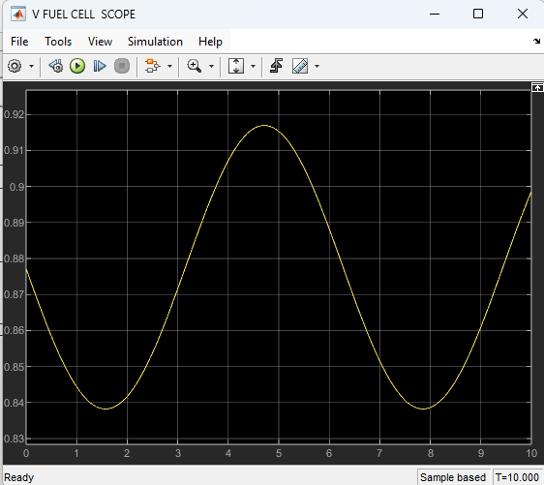

**Current:**

The output current of a single fuel cell is three amperes.

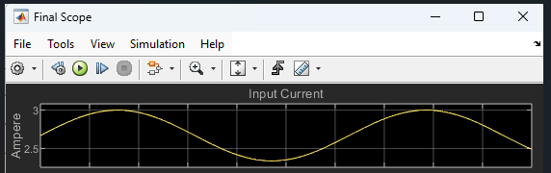  **Power:**

The power of a single fuel cell is calculated as follows

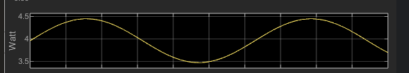

**Ohmic, Concentration and Activation Losses:**

There are three losses which reduces the efficiency of the fuel cell whose graphs are obtained from the simulation as follows

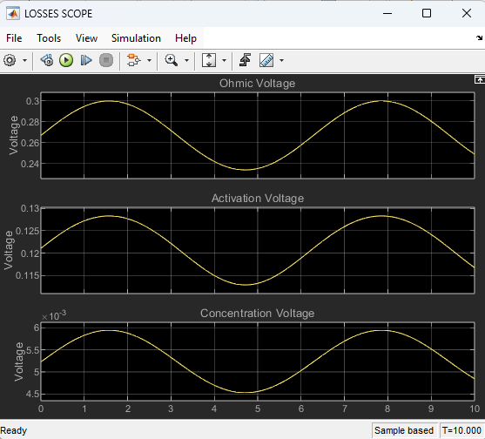  
  
**Conclusion:**  
  
A multigeneration system combining a Rankine cycle with a phosphoric acid fuel cell (PAFC ) has been studied, demonstrating the capability to generate two primary outputs: heat and power.

The system is designed to deliver an electric current between 50 and 300 amperes and a voltage range of 350 to 500 volts. Additionally, it can produce heat in the range of 20 to 80°C, which is utilized to preheat the water in the boiler. The cell stack comprises 65 cells, with a nominal efficiency of 62% after the addition of a Rankine cycle to generate electricity. It operates at a temperature of 650°C, and the nominal airflow rate is 300 litters per minute (lpm).

When evaluated in MATLAB SIMULINK, the fuel cell's current output ranges from 2.5 to 3 amperes, while its voltage output obtained is 0.92 volts of a single fuel cell. The simulated power output is between 0 and 4.5W, and the temperature output lies within the range of 20 to 80°C.